**PO2EBL_ELECTRIC BLENDER**

**HSI DOCUMENT**

**Version 1.6**

**Proposed**

# Document Status:

|  |  |  |  |
| --- | --- | --- | --- |
| **Date** | **Version** | **Document Status** | **Author** |
| 1/23/2020 | 1.1 | Draft | Amira Zaher |
| 1/26/2020 | 1.2 | Proposed | Ali Samir |
| 1/31/2020 | 1.3 | Proposed | Amira Zaher |
| 2/1/2020 | 1.4 | Proposed | Amira Zaher |
| 2/5/2020 | 1.5 | Proposed | Amira Zaher |
| 2/6/2020 | 1.6 | Proposed | Amira Zaher |

# Revision History

|  |  |  |  |
| --- | --- | --- | --- |
| **Date** | **Version** | **Description** | **Author** |
| 1/23/2020 | 1.1 | Initial Draft, mentioning all the hardware components needed for the system. | Amira Zaher |
| 1/26/2020 | 1.2 | Update Pin Mode Representation | Ali Samir |
| 1/31/2020 | 1.3 | Update the functional requirement | Amira Zaher |
| 2/1/2020 | 1.4 | Update the document header | Amira Zaher |
| 2/5/2020 | 1.5 | Adding Table of Content | Amira Zaher |
| 2/6/2020 | 1.6 | Update Functional Requirements with the number 5 requirement (Transistor) | Amira Zaher |

Contents

Document Status: 2

Revision History 3

1. Introduction 5

1.1 Hardware Requirement 5

2. Hardware System: 5

2.1 The System Block Diagram 5

2.2 Pin Mode Representation 6

3. Functional Requirements: 6

**4.** Reference Table: 7

# Introduction

This section introduces the hardware specification for the project.

## 1.1 Hardware Requirement

This specification documents all the hardware requirements for the Electric Blender including:

* Microcontroller (AVR)
* Push button
* LED
* DC motor

# Hardware System:

## 2.1 The System Block Diagram

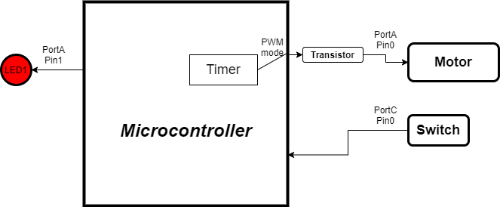

## 2.2 Pin Mode Representation

|  |  |  |  |  |  |
| --- | --- | --- | --- | --- | --- |
| **Component Name** | **Req_ID** | **Port** | **Pin** | **Mode** | **Function** |
| Motor | REQ_PO2EBL_HSI_01_V01 | Port A | Pin 0 | Digital Output PWM | Operate when it receives HIGH from the timer of the microcontroller |
| LED | REQ_PO2EBL_HSI_03_V01 | Port A | Pin 1 | Digital Output | Operate when it receives HIGH based on the state of the Motor |
| Push Button | REQ_PO2EBL_HSI_02_V01 | Port C | Pin 0 | Digital Input pull up | Gives the signal to the motor pin |
|  |  |  |  |  |  |

# Functional Requi­­rements:

|  |  |
| --- | --- |
| **REQ_ID** | **Description** |
| REQ_PO2EBL_HSI_01_V01 | * DC motor (2 pins: microcontroller O/P pin and GND)   #imp HW |
| REQ_PO2EBL_HSI_02_V01 | * Push Button (2 pins: microcontroller I/P pin and GND)   #imp HW |
| REQ_PO2EBL_HSI_03_V01 | * LED (2 pins: microcontroller O/P pin and GND)   #imp HW |
| REQ_PO2EBL_HSI_04_V01 | * AVR Atmega32 microcontroller (32 DIO pins)   #imp HW |
| REQ_PO2EBL_HSI_05_V01 | * Transistor to maintain the isolation level between the microcontroller and the motor acts as Safety Monitor   #imp HW |

# Reference Table:

|  |  |  |  |
| --- | --- | --- | --- |
| **ID** | **Version** | **Status** | **Document** |
| 1 | 1.0 | Released | Electric Blender customer requirement |
| 2 | - | - | SIQ |